THRACE – Report of modifications implemented following the external evaluation
November 2025
Context
Evaluation conducted in.. by… with action detailed in…
Confidence of freedom
IMPROVE DATA ENTRY
R2. Countries should not report the number of animals sampled, but the number of animals tested for each disease. Alternatively, this can be addressed manually in the model code so that the numbers sampled are correctly displayed in the Web interface
Action | - change the model code to use the correct number of animals tested as input  - check possibility for countries to report on tests performed  - amend database format allowing the reporting of the animals tested vs animals sampled
Responsibility | EuFMD (a - b - c)  Countries – focal points (b-c)
Timeline | End of the year (a)  March 2026 (b – c)
Action implemented in November 2025
- The current protocol of sampling and testing, and the modifications to this protocol done through the years have been documented.
Protocol:
Disease | Country | Period | Clinical testing | Serological testing
FMD | Greece | 2016-2025 | Random sample computed with 2% herd prevalence, 20% animal prevalence, among the high risk epiunits?  Each quarter? | All animals clinically examined
 | Bulgaria
 | Türkiye
PPR | Greece | 2022-June 2024 |  | ¼ of animals clinically examined
 |  | July 2024-2025 |  | All animals clinically examined
 | Bulgaria | 2022 - 2025 |  | All animals clinically examined
 | Türkiye | 2022 - 2025 |  | Not tested
LSD / SPGP | Greece | 2022 - 2025 |  | Not tested
 | Bulgaria | 2022 - 2025 |  | Not tested
 | Türkiye | 2022 - 2025 |  | Not tested
Coverage: any changes to report? Number of epiunits under surveillance = all epiunits in the region?
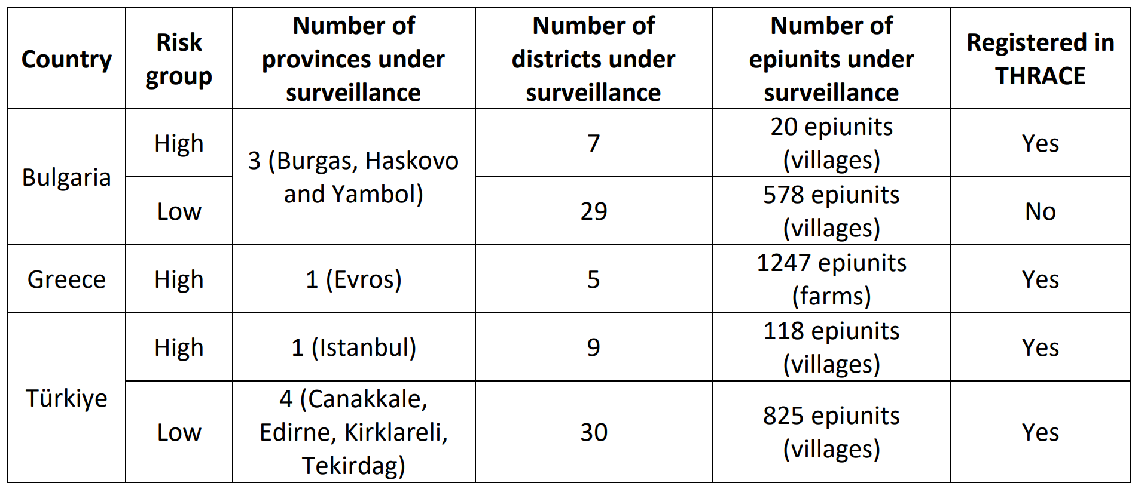

- The following changes have been implemented in the factivities table:
  - Column cattletested created;
  - Column sheeptested created;
  - Column goattested created;
  - Column pigtested created;
  - Column buffalotested created;
  - Column wildtested created.
- Values of the columns created in step 2) have been informed in the factivities table according to 1), as follows:
  - TO DO
- The following changes have been implemented in the update_database_2025.sql script:
  - Changes to the thrace.create_data_summary procedure:
    - Change lines 397-403
From:
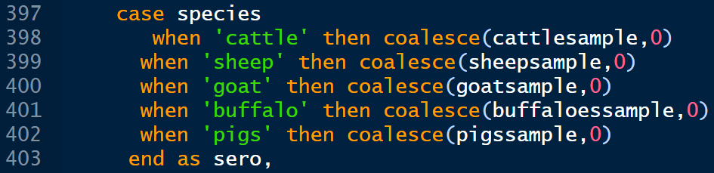
To:
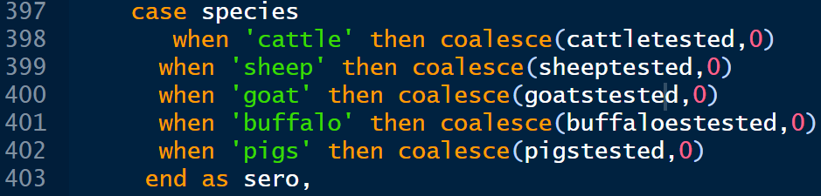
    - Lines 498/499 erased
Follow-up
- check possibility for countries to report on animals sampled and tests performed;
- change web application to be able to inform the number of tests performed (columns created in step 2) ) directly by the user, instead of computing it from the number of samples.

R3. Given the additional workload required and the little added value, the collection of inventory data in THRACE could be suspended.

Action | Due to the relevance of inventory data for the overall knowledge of the situation in the region, continue the annual collection of these data, but implement regular checks against data from field visits to identify and correct inconsistencies
Responsibility | EuFMD
Timeline | End of the year for the database
Action implemented in November 2025
- A process to compare the sum of population size in each epiunits sampled tot the inventory figure reported has been implemented (see code hereunder) and will be run periodically after the last report of the year.

To do
Follow-up
- Make the reporting of inventory data mandatory for each first report of the year.
- Follow-up potential discrepancies with National Focal points.

R4. Modify the database structure and the Web interface to associate a “risk group” field (value “low” or “high”) to each epiunit. Alternatively, the risk group could be assigned to an entire district, or an entire province.

Action implemented in November 2025
- The following changes have been implemented in the epiunits table:
  - Column risklevel created.
- Values of the column created in step 1) have been informed as follows:
  - Bulgaria
Values of the column risklevel in epiunits table were updated according to the following list of high risk epiunits
epiunitID | epiunitname | risklevel
2145 | BELEVREN | high
2153 | BLIZNAK | high
2150 | BRODILOVO | high
2159 | FILIPOVO | high
2162 | GOLYAM DERVENT | high
2147 | GORNO YABALKOVO | high
2156 | KAPITAN ANDREEVO | high
2149 | KOSTI | high
2164 | KRAYNOVO | high
2160 | LESOVO | high
2152 | MALKO TARNOVO | high
2155 | MATOCHINA | high
2158 | PRISADETS | high
2157 | RADOVETS | high
2154 | SHTIT | high
2148 | SINEMORETS | high
2151 | SLIVAROVO | high
2163 | STRANDZHA | high
2146 | TRAKIITSI | high
2161 | VALCHA POLYANA | high
All others in BURGAS, HASKOVO and YAMBOL provinces |  | low
Code:
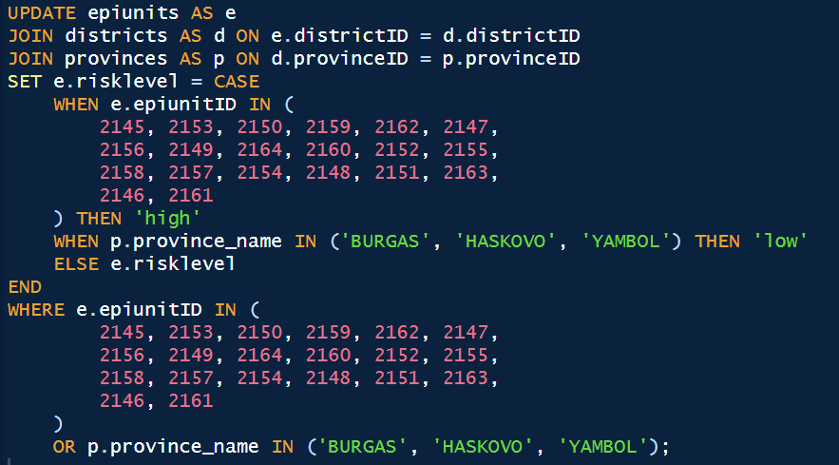

  - Türkiye
Values of the column risklevel in epiunits table were updated according to the following list of high risk epiunits
Country | Risk group | Number of provinces under surveillance | Number of districts under surveillance | Number of epiunits under surveillance | Registered in THRACE
Türkiye | High | 1 (Istanbul) | 9 | 118 epiunits (villages) | Yes
 | Low | 4 (Canakkale, Edirne, Kirklareli, Tekirdag) | 30 | 825 epiunits (villages) | Yes

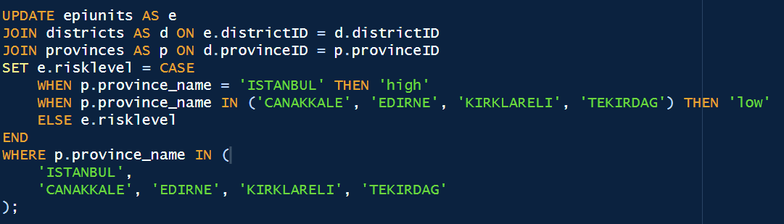
  - Greece
Even if all epiunits from Greece as considered as high risk, and that risk-based computation will not be performed for Greece, the column risklevel in epiunits table has been updated.
Code:
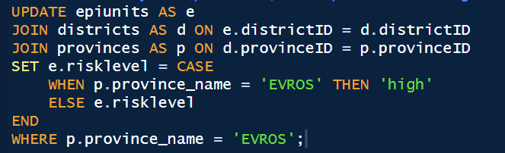

- Changes to the thrace.create_data_summary procedure
  - Line 389 erased
The corresponding information will be imported from the epiunits table at line 465
  - Column name changed in line 606 from
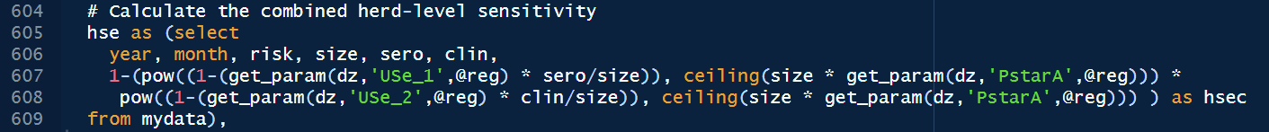
To
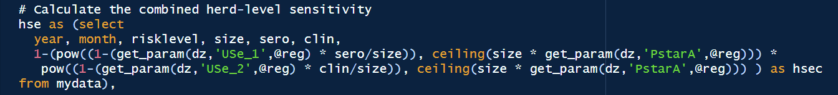
  - Column name changed in lines 615 and 617 from
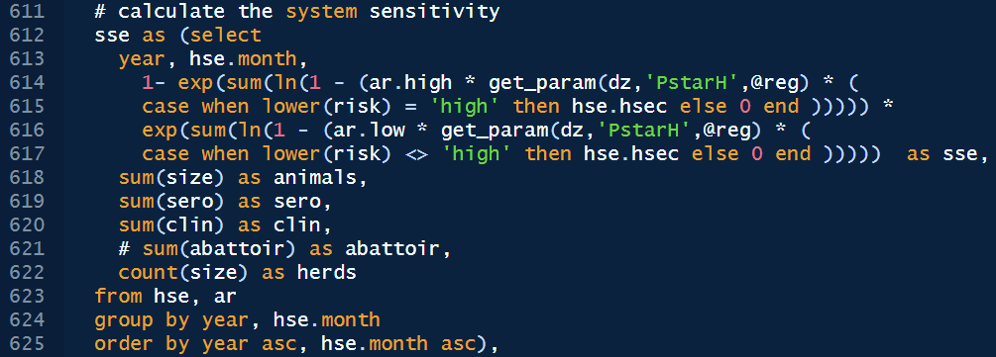
To
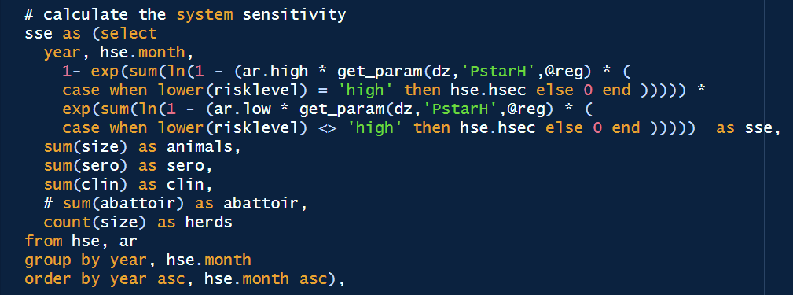

R5. The Cycle Reports should also be modified to present the risk group associated with the different provinces (Türkiye) or districts (Bulgaria and Greece).

Action | Change the database format allowing the attribution of risk levels to different epi units or epi-groups
Responsibility | EuFMD
Timeline | End of the year

-> procedure creating the excel file should be edited to include a “risk level” column in the DATA_BR, DATA_TR and DATA_GR report, from the thrace.epiunit risklevel column
-> To check if we have to change the app or not
R6. Include the 578 low-risk epiunits in the three provinces under surveillance in Bulgaria in the “epiunits” database table. Update the “districts” and “provinces” database tables accordingly.

Action | - Check the possibility for Bulgaria to share information on the low risk epiunits, obtained through the national surveillance programme.  - Modify the database and the code to allow reporting of these data and inclusion in the computation.
Responsibility | EuFMD (a-b)  Bulgaria – focal points (a)
Timeline | End of the year
-> to liaise with Bulgaria first: meat Pilar/Goran/NFP BR and myself on it.
-> to check what would be needed to modify it (logic of login, data entry and so on)
-> to check if any modification of code needed (I don’t think so)
CORRECT MODEL CALCULATION and PARAMETERS
R1. The calculation of the combined herd-level sensitivity does not account for the overlap between the two surveillance components (serological and clinical) and should be corrected.
Action | Change the formula to take into account the combined herd-level sensitivity where both clinical examination and serological sampling are conducted
Responsibility | EuFMD
Timeline | end of the year
Action implemented
The former procedure to compute the system sensitivity was the following:
- Step 1: Compute for each herd the combined herd sensitivity, from the herd sensitivity for the clinical component and the herd sensitivity for the serological component.
- Step 2: Compute the system sensitivity from each herd combined sensitivity
As this procedure did not account for overlapping between the two surveillance components, we adopted the procedure described by Cameron et al. (FAO, 2014), p. 147:
- Computing for the first component sensitivity, from the herd level sensitivity and the effective probability of infection (EPI – computed from herd level design prevalence and adjusted risk);
- Computing the posterior probability that the herd is infected after component 1;
- Computing the second component sensitivity, but considering the posterior probability that the herd is infected from the previous component as a prior probability of infection when computing the EPI.
- Computing system sensitivity from component 1 sensitivity and component 2 sensitivity.
The following changes have been implemented in the update_database_2025.sql script:
From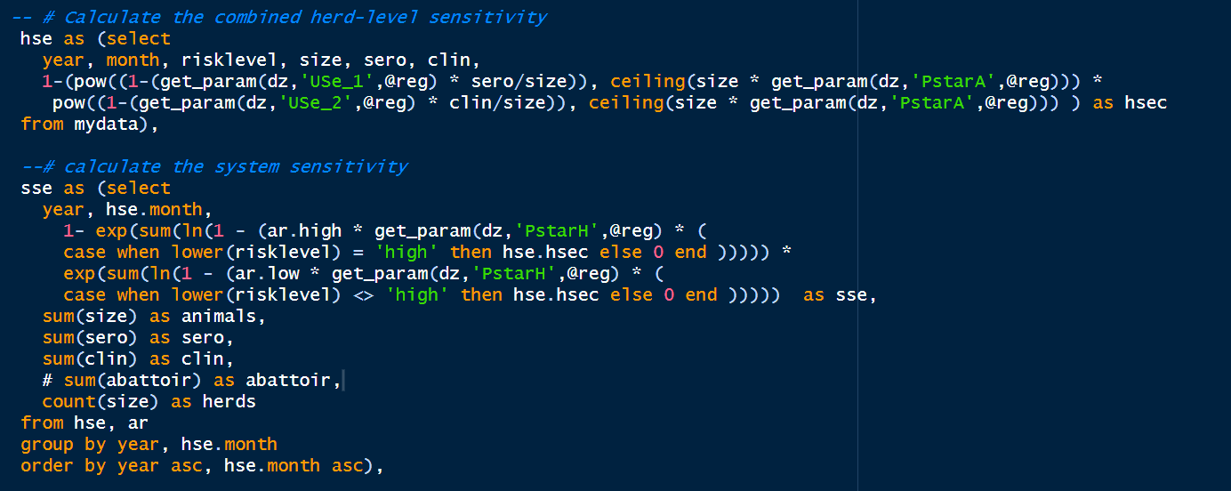
To
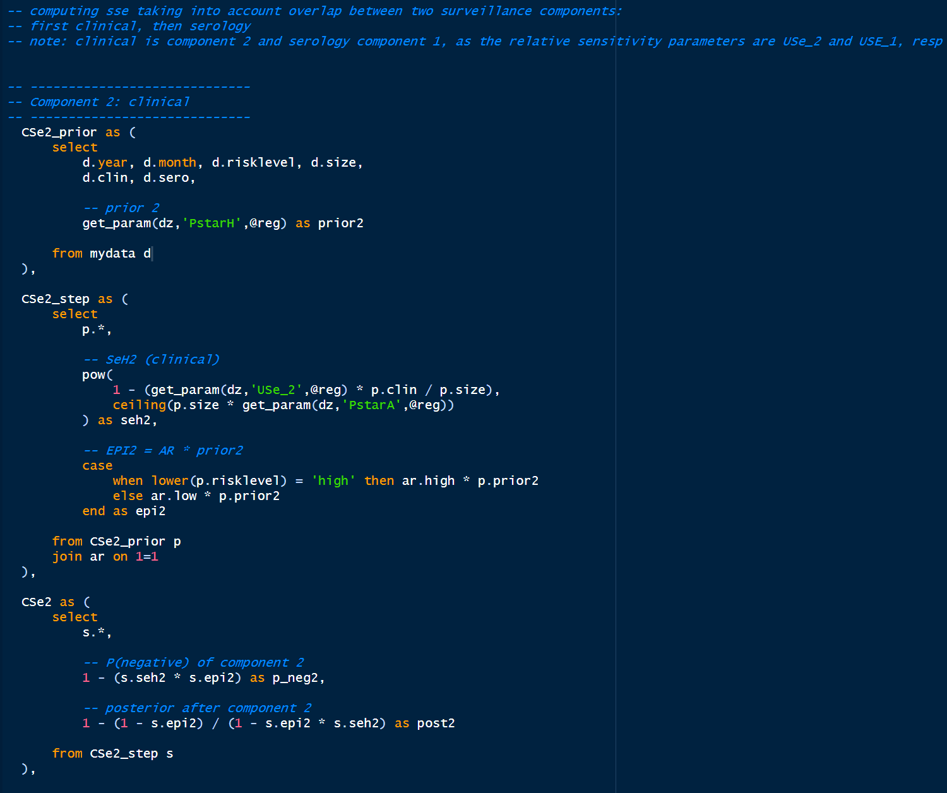
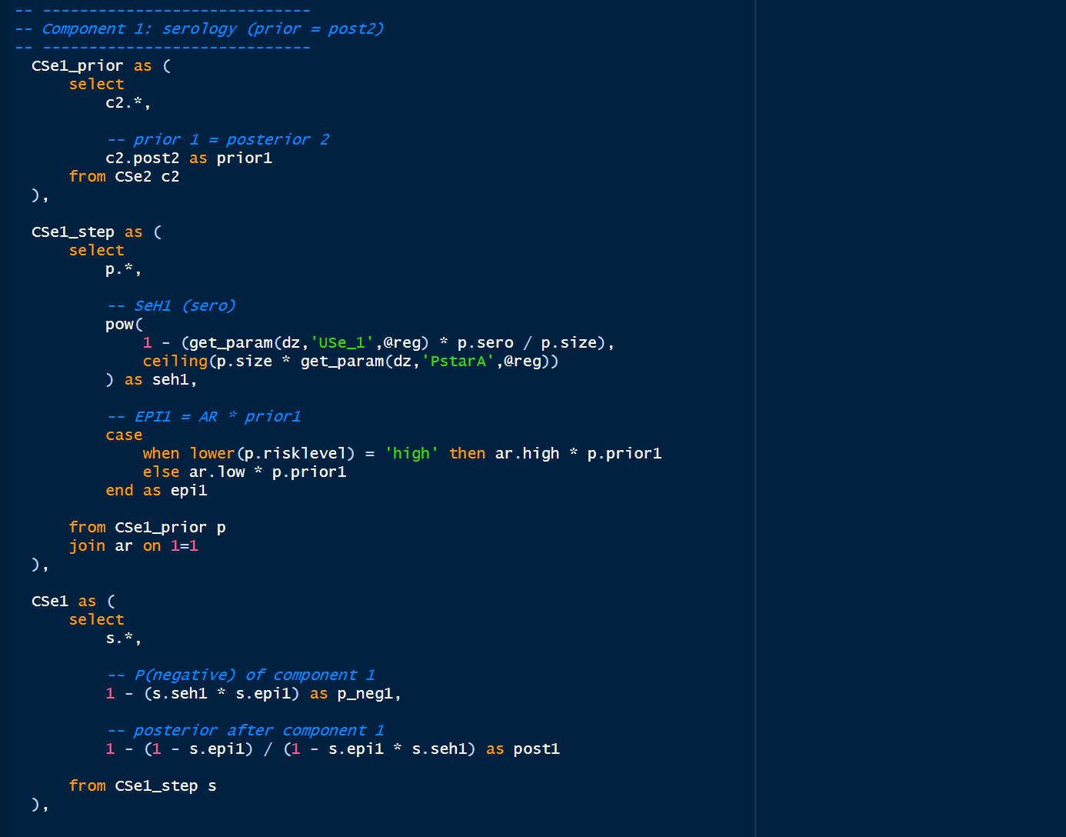
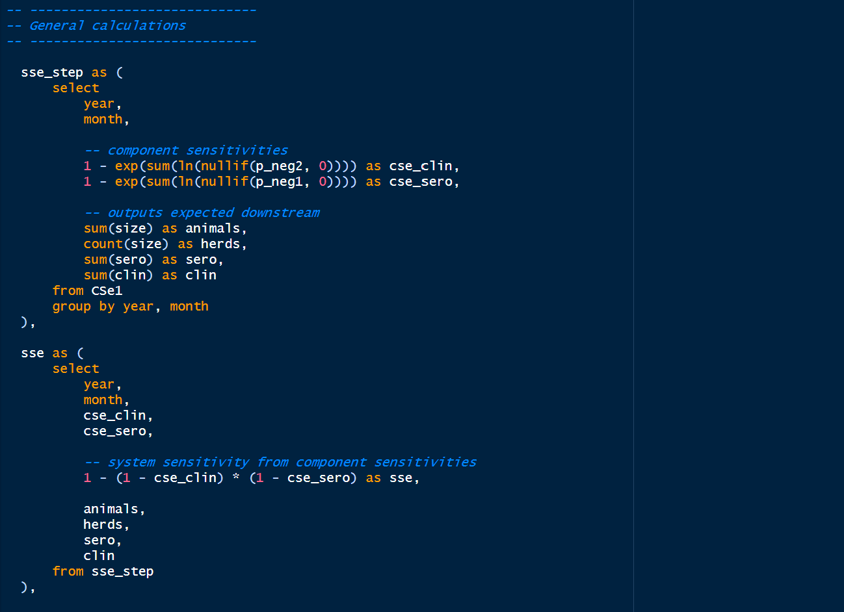
R7. The model procedure should be corrected to avoid the calculation errors. We suggest modifying the “get_param” function in the database so that it returns the value as a DOUBLE instead of a FLOAT

Action | Correct the formula
Responsibility | EuFMD
Timeline | End of the year
The function get_param has been changed from
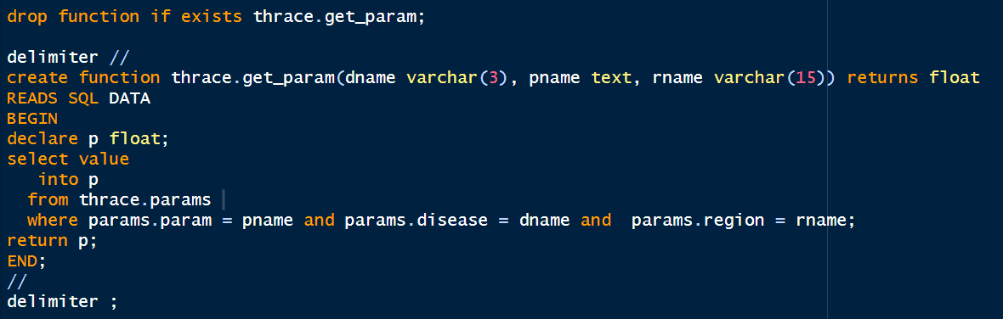
To
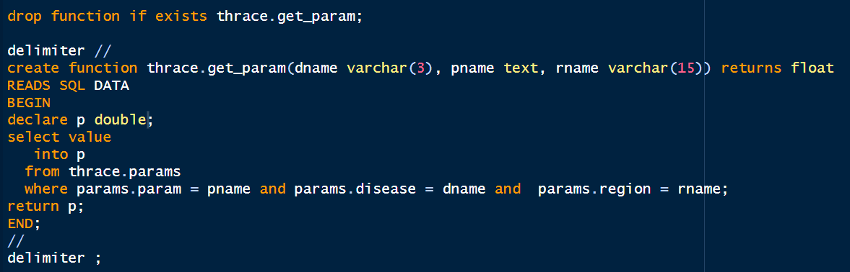

R8. The model procedure to estimate the all-species surveillance sensitivity should be corrected to avoid assuming independence between species.

Action | Correct the formula
Responsibility | EuFMD
Timeline | End of the year
Action implemented
The following code has been added in the update_database_2025.sql procedure, after creation of the all_data table:
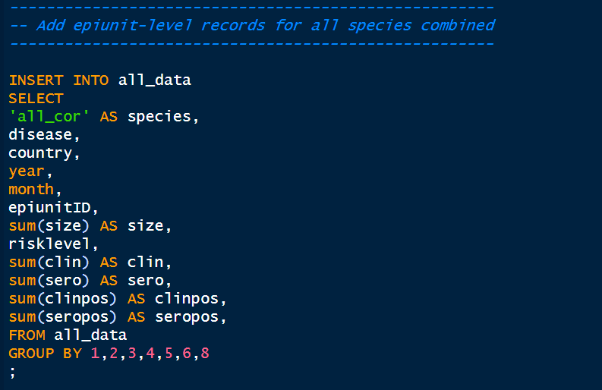
R9. The region-wide results are incorrect for PPR surveillance. These results are also unlikely to be of use, given that the implementation of THRACE is very different between countries. Therefore, we suggest removing the region-wide sensitivity calculations from the model procedure.

Action | Remove the region-wide sensitivity calculations from the model procedure
Responsibility | EuFMD
Timeline | End of the year
Action implemented
- The region-wide specific parameters have been erased from the update_database_2025.sql procedure
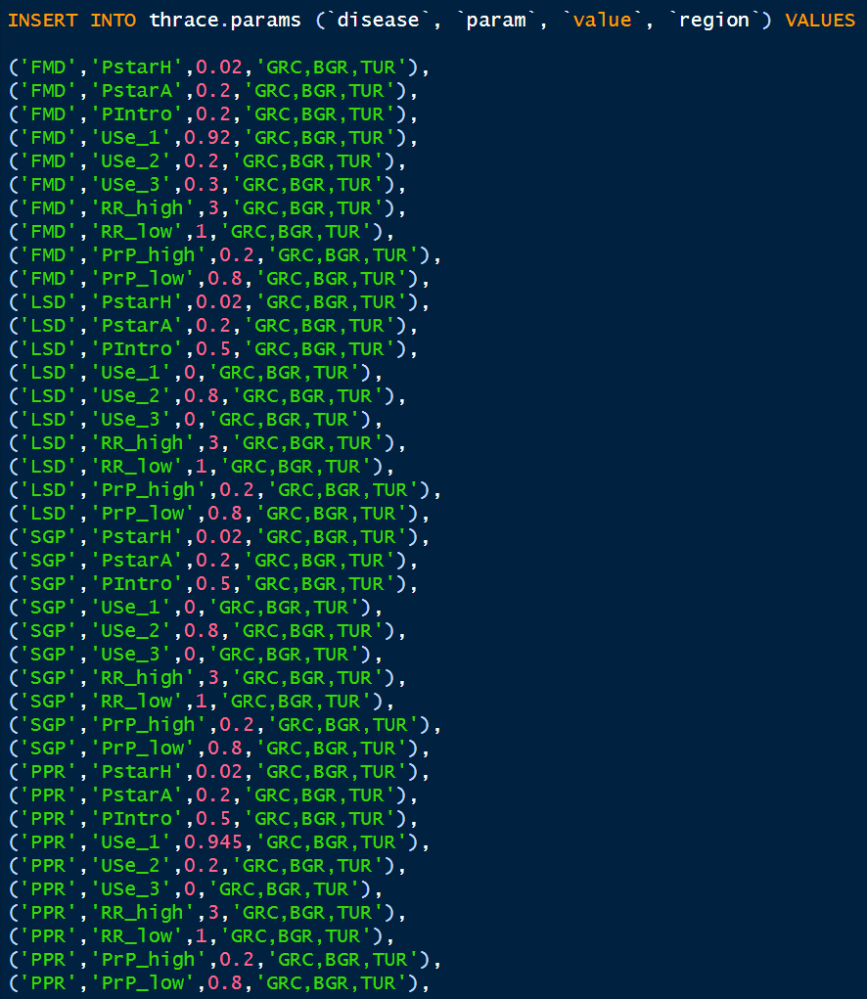
- In the get_freedom_data function, the following code has been changed in the update_database_2025.sql procedure
From
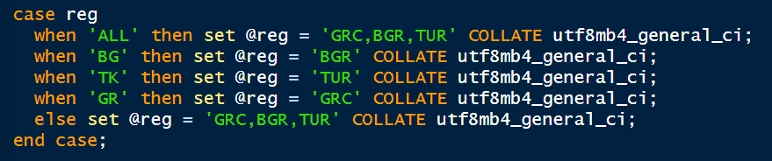
To
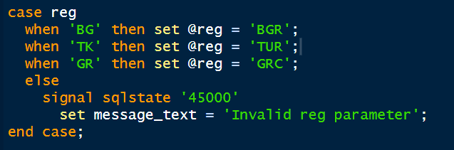
-> frontend to be changed to avoid displaying it also: value as NA or something like this, to avoid changing the application

R10. Investigate whether accounting for the effect of vaccination on the sensitivity of clinical surveillance in the model is necessary. This would require recording the occurrence of vaccination in the database, so that the correct unit sensitivity can be used for a given time and location, as well as changes in the model parameters and calculations

Action | - Assess the feasibility of collecting vaccination data in the THRACE database  - Assess effect of vaccination on clinical surveillance sensitivity
Responsibility | EuFMD (a-b)  Countries – focal points (a)
Timeline | March 2026

- To be done for next THRACE meeting

R11. The monthly probabilities of introduction could be made disease-specific, given that the disease pressure is not identical for all FAST diseases. In addition, they could also be made country specific. To achieve this, one or two additional fields should be added in the “monthly_pintro” table (“disease” and/or “country”), and the model procedure should be adjusted, making using of the existing “get_param” function

Action | - add fields in the ‘monthly_pintro’ table and adapt the model calculation  - Revise the monthly probabilities of introduction for FMD and make them country-specific according to expert elicitation and looking at recent epi situation and other modelling tools.  - Define the country-specific monthly probabilities of introduction for PPR and SPGP.  - Update the annual and monthly risk value at the beginning of each year
Responsibility | EuFMD (a-b-c-d)  Countries (b-c)
Timeline | - end of the year  - March 2026  - March 2026  - Annually
-> I’ll check and change the code
-> to check how the app is reading it

R12. We suggest correcting the values in the “monthly_pintro” table for 2024 onwards. An Excel spreadsheet “Pintro_monthly_calculations” is provided with this report to disaggregate the annual risk (which can be disease-specific, see above) into monthly risks according to the original formula proposed by Ausvet.

Action | - Correct values and associated formula to disaggregate the annual risk in the ‘monthly_pintro’ table (sum of monthly valuesshould correspond to annual probability)
Responsibility | EuFMD (a)
Timeline | February 2026

Action implemented
The values of the monthly_pintro table from 2024 onward have been corrected as follows:
Probability of introduction (since 2024)
Annual P(intro) | 0.2
Month | Monthly relative risk score | Adjusted P(intro) | Values in the DB currently
1 | 1 | 0.00694898 | 0.006179261331
2 | 1 | 0.00694898 | 0.006179261331
3 | 3 | 0.02070241 | 0.01842347013
4 | 3 | 0.02070241 | 0.01842347013
5 | 4 | 0.02750753 | 0.02448888802
6 | 6 | 0.04097623 | 0.036507516
7 | 5 | 0.03426536 | 0.03051682611
8 | 3 | 0.02070241 | 0.01842347013
9 | 3 | 0.02070241 | 0.01842347013
10 | 1 | 0.00694898 | 0.006179261331
11 | 1 | 0.00694898 | 0.006179261331
12 | 1 | 0.00694898 | 0.006179261331
 | Equivalent annual P(intro) | 0.200 | 0.180

R13. Adjust the parameters related to the proportion of the population in each risk group for Bulgaria, with PrP_high = 0.03 and PrP_low=0.97.

Action | - adjust parameters for Bulgaria
Responsibility | EuFMD (a)
Timeline | End of 2025

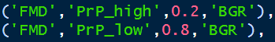
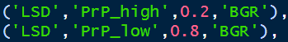
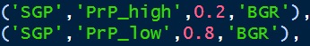
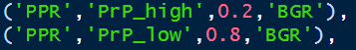
To
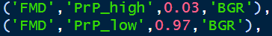
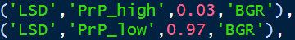
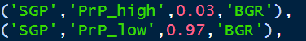
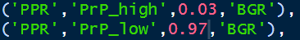

R14. The sampling cannot be considered as risk based in Greece given that all epiunits are in the same risk group (no low-risk epiunits or animals in the province under surveillance). Therefore, the sensitivity calculations should be corrected for this country. Alternatively, the epiunits in Evros could be divided into two different risk groups and treated accordingly in the analysis.

Action | - adjust calculation for Greece  - Re-evaluate relative risks between epiunits for Greece
Responsibility | EuFMD (a)  EuFMD – Greece (b)
Timeline | End of 2025  March 2026 (b)
Action implemented
Among to solutions suggested, we chose the conservative approach of defining relative risks parameters to 1 for Greece. Indeed, this solution allows to easily reconsider a risk-based approach for Greece should risk levels be modified for this country.
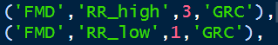
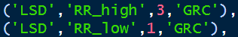
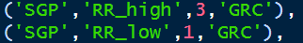
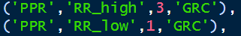
To
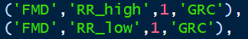
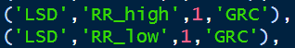
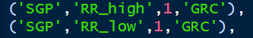
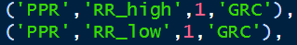

R15. Adjust the parameters related to the proportion of the population in each risk group for Türkiye, with PrP_high = 0.13 and PrP_low=0.87.

Action | - adjust parameters for Turkiye
Responsibility | EuFMD (a)
Timeline | End of 2025
Action implemented
The parameter values have been changed in the
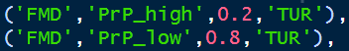
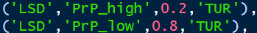
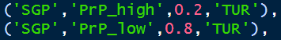
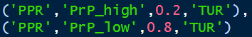

To
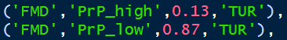
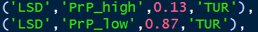
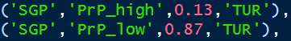
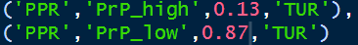
R16. Modify the database procedure used to create the “all_data” table to recover the risk group associated with each epiunit in the “epiunits” table instead of assigning a default value
Action | - adjust parameters
Responsibility | EuFMD (a)
Timeline | End of 2025

- see action implemented for R4.

R20. Reconsider the value of 3 used for the relative risk in high-risk epiunits in the light of recent outbreaks, accounting for differences between countries and diseases, especially for SPGP and PPR programme documentation and outputs

Action | Expert elicitation to reconsider the relative risk in high-risk epiunits in the light of recent outbreaks, accounting for differences between countries and diseases, especially for SPGP and PPR
Responsibility | EuFMD and countries
Timeline | March 2026

- To be done for next THRACE meeting

R23. Modify the model SQL procedure so that all calculated variables and parameters at visit and epiunit level are recorded as new columns in the “all_data” table.

- To be changed, but more work. Probably to be done first as might impact other code modifications
- To be done next year when we save

R24. Modify the model SQL procedure currently implemented via the “get_freedom_data” function to create a permanent table containing all the model outputs: system-level sensitivity, probability of introduction, probability of freedom by country, disease, species and month.

Action | Modify SQL procedures
Responsibility | EuFMD
Timeline | End of 2025

- To be changed, but more work. Probably to be done first as might impact other code modifications

IMPROVE MODEL TRANSPARENCY
R21. Create a technical documentation of the model approach, calculations and assumptions.

- What deadline? March 2026

R22. Document the changes to the model approach, calculations and assumptions in a formal way.

Action | - Technical model documentation: model approach, assumptions, calculations and parameters  - Document all model changes using a continuously updated technical document and/or version control tools.
Responsibility | EuFMD
Timeline | As soon as modifications are done

- ongoing

R26. Cycle Reports should include the date at which they are generated, given that the data may change in time.

- Process creating the excel file to be changed

R27. The column labels for columns L to P are not descriptive enough: the headers are in the form “N. Cattle” without specifying the calculation that is performed. An accurate header would be “Avg N. Cattle / Epiunit” instead.

- To be agreed and changed in the process creating the excel file
- WE NEED THE SAMPLE OF EXACTLY WHAT NAMING THEY WANT

R28. The total number of animals in epiunits visited that quarter could be a more useful quantity. This could be approximated by using the size collected during the most recent visit for each epiunit.

Action | Modify database and cycle report to be more explicit and useful
Responsibility | EuFMD
Timeline | End of 2025

- To be agreed and changed in the process creating the excel file
- It would probably need to change the app, so to put on hold for now.

R29. Introduce a formal mechanism to record FAST disease outbreaks occurring in the areas under surveillance. This information should then be used in the Web interface and Cycle Reports to display or not display the probability of freedom for a given country, disease and quarter.

Action | Modify database to collect such information and define report modality
Responsibility | EuFMD – countries
Timeline | End of 2025

-> input possibility on the platform, deactivation of disease freedom to be implemented
-> should we take that into account as a prior in the next iteration of confidence of freedom?

Early detection
CALCULATION
R17. In Bulgaria, the current P*H value of 2.0% is slightly too low given the small number of high-risk epiunits.

- value to be changed

R18. The value chosen for the herd-level design prevalence for Greece and Türkiye is also important in the context of THRACE’s early detection objective, which requires that the disease is detected before it spreads to a large proportion of the population. Consider using lower values for the herd-level design prevalence in these two countries to remain in adequation with the early detection objective of the programme.

Action | For the objective of early detection:  - Increase the herd-level design prevalence P value for Bulgaria  - decrease the value of the design prevalence for Greece and Turkiye  - decrease values for the herd-level design prevalence for Greece and Turkiye
Responsibility | EuFMD (a)
Timeline | January 2026

- values to be changed

R19. The value chosen for the animal-level design prevalence is also important in the context of early detection surveillance. Consider whether the animal-level design prevalence P*A of 20% currently used in THRACE is in adequation with the early detection objective of the programme

Action | Change the animal-level design prevalence P value (ideally according to the herd size)  See ‘early detection’ recommendations
Responsibility | EuFMD
Timeline | January 2026
- values to be discussed

R30. adding the early detection surveillance sensitivity calculation, using the alternative formula to THRACE’s model procedure.

Action | Include calculation of EDSe using the suggested formula.
Responsibility | EuFMD
Timeline | March 2026

Computation to be implemented (SQL procedure) and displayed on both cycle report and web app
Question to andrea too

PASSIVE/ACTIVE SURVEILLANCE
Overall, a functioning passive surveillance system is the gold standard for successful early detection of livestock diseases. With THRACE’s new objective to detect incursions of FAST diseases in Thrace in a timely manner, there is a need to reorientate efforts and resources towards passive surveillance in the region. Active surveillance may still contribute to the early detection objectives, but it requires several improvements. Improvements of both components are further described below.

Passive surveillance

- Farmer reporting
  - Enhance farmer engagement with specifically-designed awareness activities (clinical signs, importance, reporting routes, etc.)
  - Work with national authorities to remove potential disincentives, if any, and increase incentives to reporting: compensation in outbreaks, reporting pathways, etc
- Target veterinarians with training and awareness activities (i.e opportunistic clinical surveillance)

Active surveillance
- Population coverage.
Efforts to increase the population coverage would be beneficial in Greece and Bulgaria:
  - For Greece, the focus should be on increasing the proportion of epiunits visited each month. Given the size of the province under surveillance, and the logistical constraints already reported by the national consultant, this would require additional human resources to cover the area with a sufficient frequency. Alternatively, the option to delegate the clinical surveillance visits to official veterinarians, as currently arranged in Bulgaria and Türkiye
  - For Bulgaria, the focus should be on reaching an agreement with the veterinary services so that they submit data on the active surveillance conducted in the low-risk areas of Burgas, Haskovo and Yambol. Should blind spots be identified after assessing the value of these surveillance activities, additional surveillance in the low-risk epiunits could be considered by EuFMD.
- Epiunit-level sensitivity.
  - In Türkiye, the clinical examinations focus heavily on cattle. While this was favorable to the detection of FMD, it is lowering the surveillance performance observed for PPR and SPGP. The proportion of the small ruminants present by epiunit that are currently clinically examined is generally very low. The programme should identify the obstacles to increase the clinical examination of small ruminants in Türkiye, especially in the high-risk area. Individual clinical examination of small ruminants may be more time consuming and less practical (e.g., animal restraint) than that of cattle. Then, measures to increase the number of clinical examinations per visit should be implemented**
  - In Bulgaria, the contribution of the serology component to the surveillance sensitivity was minimal for both FMD and PPR. Dropping this component would not affect the surveillance sensitivity significantly but would free resources which could be redirected to the clinical component instead, either in the high- or low-risk villages, as discussed above.
- Risk-based approach.
As mentioned previously, the identification of the high-risk areas within the Thrace region and the parametrisation of the relative risk parameters were conducted for FMD specifically. FAST diseases that are specific of small ruminants (PPR, SGP) may behave differently. Parameters should be updated to reflect recent experience and knowledge with these diseases.

Action | - Countries to include data from TADs project in the database (by end of the year)  - Deliver passive surveillance course in local languages for vets working in risk areas  - Review and reshare awareness material available in local languages  - Reevaluate spatial and temporal risk and update parameters in the model / increase population coverage Greece*-Türkiye** (by March 2026) see - R11 and R20  - Evaluate the contribution of serological surveillance in high risk epiunits of Bulgaria  - Organize 3 workshop at local level with vets/private sector on awareness, reporting, biosecurity with behavioral science expert  - Continue regular tripartite meeting with regular monitoring of risk using the RMT
Responsibility | a – countries  b,c,d,e,f – EuFMD and countries
Timeline | a - End 2025  b – March 2026  c - End 2025  d – March 2026  e- March 2026  f - June of 2026  g - March/Sept 2026

Unspecific health data reporting by farmers
Surveillance activities which have shown better performance for early detection should be considered in addition to or in replacement of the existing components. In particular, unspecific health data already reported by farmers to the competent authorities on livestock mortality and abortion rates for example could be utilised for surveillance of FAST diseases in the Thrace area. The abortion rates in particular could support surveillance of RVF, which is not currently accounted for in THRACE. Such data could be obtained from existing national electronic animal health data management systems such as VETIS in Türkiye or other sources such as private veterinarian data management systems

Action | Verify possibility to include reports of abortions info collected by countries in the database
Responsibility | EuFMD
Timeline | March 2026

